# Python Setup

The following steps are for Windows users; if you are using Linux and Mac, please use this link: <https://docs.conda.io/projects/conda/en/latest/user-guide/install/index.html>

1. Download Anaconda, <https://www.anaconda.com/download/>. Choose Python 3.X.
2. **Install, confirm and update Anaconda (about 10 minutes or more).** 
   1. Double click the downloaded file, e.g., Anaconda2-5.0.1-Windows-x86_64.exe, and follow the installation wizard. **Remember to select the option that adds Anaconda to PATH; if you forget, go to step 2.2; if not, jump to 2.3.**
   2. Manually adding Anaconda to the PATH variable (windows)

1) Open the Start menu, start typing "environment" and select the option called **Edit the system environment variables**

2) Select the **Environment Variables button n**ear the bottom

3) In the top section containing user variables, select the one called **Path** and choose to edit it

4) Add the location of the "**Scripts**" folder and the **Anaconda** folder

* 1. Check the Anaconda and Python versions: open a terminal/command line (**Win + R 🡪 cmd** or search and run **Command Prompt**), and type

*conda -V*

*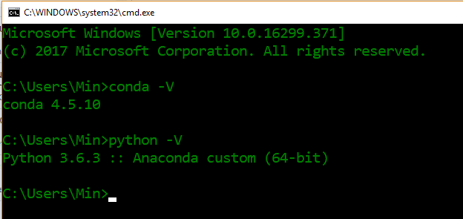python –*

* 1. Confirm your conda is up-to-date by typing

*conda update conda*

*conda update anaconda*

***You may need to input ‘Y’ to allow the update all some packages.***

* 1. Check the versions of the SciPy, numPy, Matplotlib, Pandas, and Scikit-learn packages by using checkversions.py

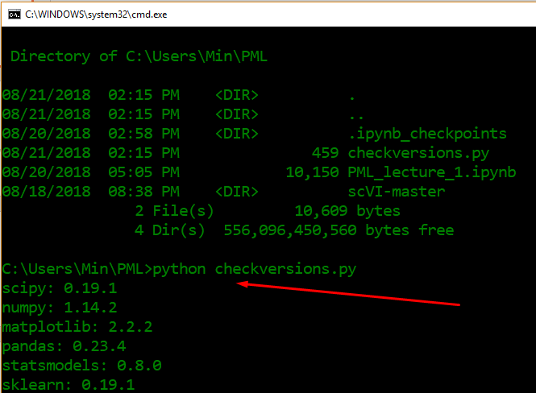

*# checkversion.py*

*# scipy*

*import scipy*

*print('scipy: %s' % scipy.__version__)*

*# numpy*

*import numpy*

*print('numpy: %s' % numpy.__version__)*

*# matplotlib*

*import matplotlib*

*print('matplotlib: %s' % matplotlib.__version__)*

*# pandas*

*import pandas*

*print('pandas: %s' % pandas.__version__)*

*# statsmodels*

*import statsmodels*

*print('statsmodels: %s' % statsmodels.__version__)*

*# scikit-learn*

*import sklearn*

*print('sklearn: %s' % sklearn.__version__)*

1. **Install Deep Learning Libraries (not required at the current stage)**

3.1. use anaconda cloud (<https://anaconda.org/anaconda/repo>)

1) search package, e.g., tensorflow

2) copy the ‘***conda install –c conda-forge tensorflow***’ command and run in your terminal

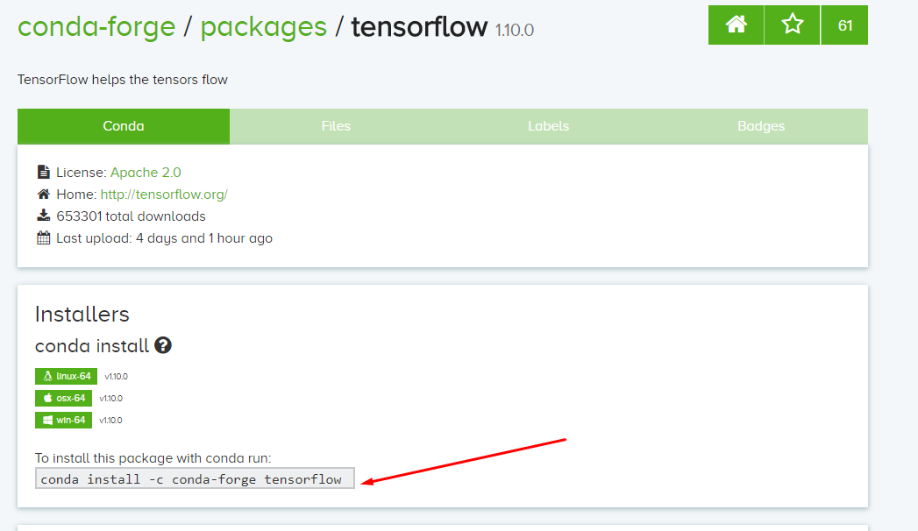

* 1. Or you can use **pip** to install

*pip install --upgrade tensorflow*

3.3 Check tensorflow version (*tensorflow* requires python 3 on Windows)

*Python*

*import tensorflow as tf*

*tf.__version__*

# Use Jupyter Notebook

1. Search and run Jupyter Notebook

If the notebook is not installed, type the following command

*conda install jupyter*

to install the latest version of jupytor notebook.

2. It opens your default browser, and you can use the **New** button to create your Python file (as shown in the following Fig.)

